**IDC2 Documentation**

1. Inspiration

My roommates stay up later than me and are often very loud to the point where I cannot fall asleep. I wanted to create something that would tell them to be quieter without me having to text them. The goal is not to be silent but just normal volume levels (i.e no shouting at the tv or blasting music). I wanted the object to look cute, so I decided on a teddy bear theme. A teddy bear yelling at people should catch them off guard enough to listen to it.

1. Circut

I started off by creating a circuit with just the sound sensor to test its values. That worked so I soldered it. I then added my mp3 player and speaker to the circuit on a breakout board. At first I could not figure out why it was not playing the recordings. We figured out it was a combination of two things. The TX and RX pins needed to be switched and the mp3 files needed to be changed to a smaller format (lower quality). Once that worked I soldered the mp3 player and its wires. After about 2 weeks the circuit was running.

1. Code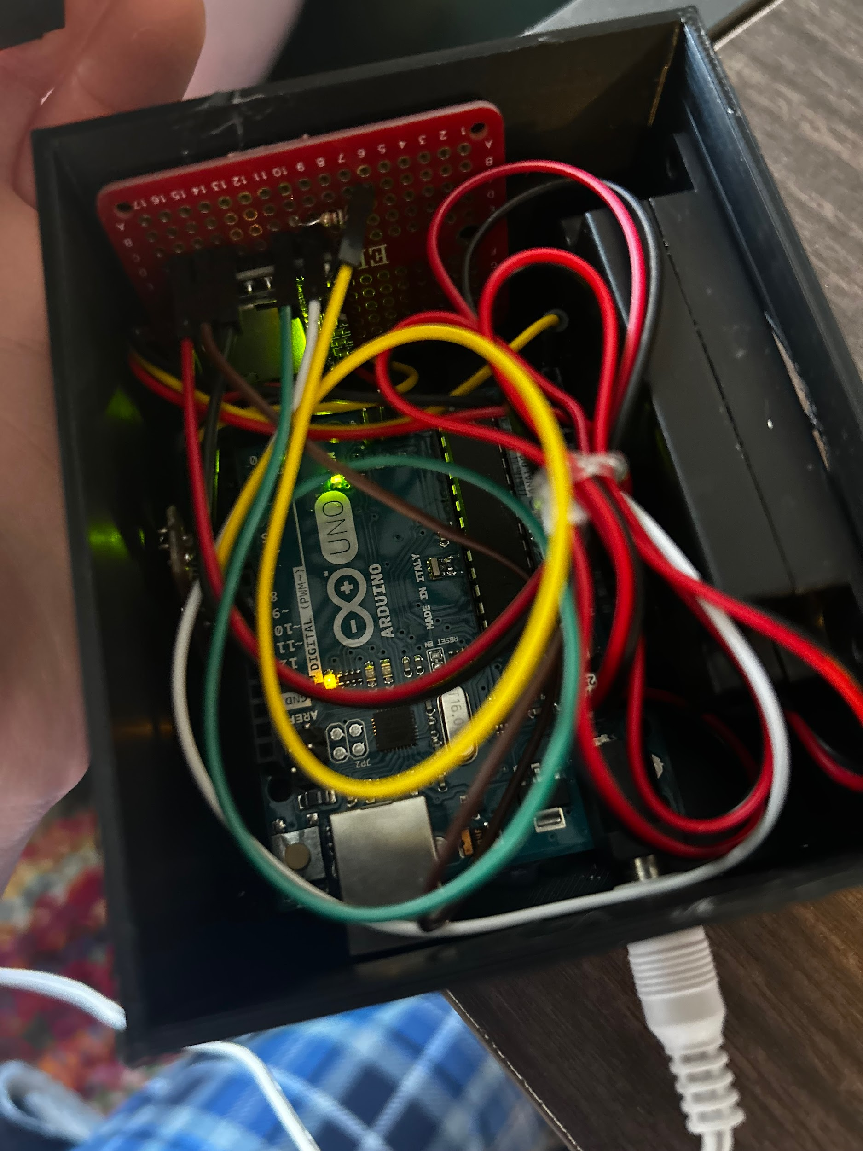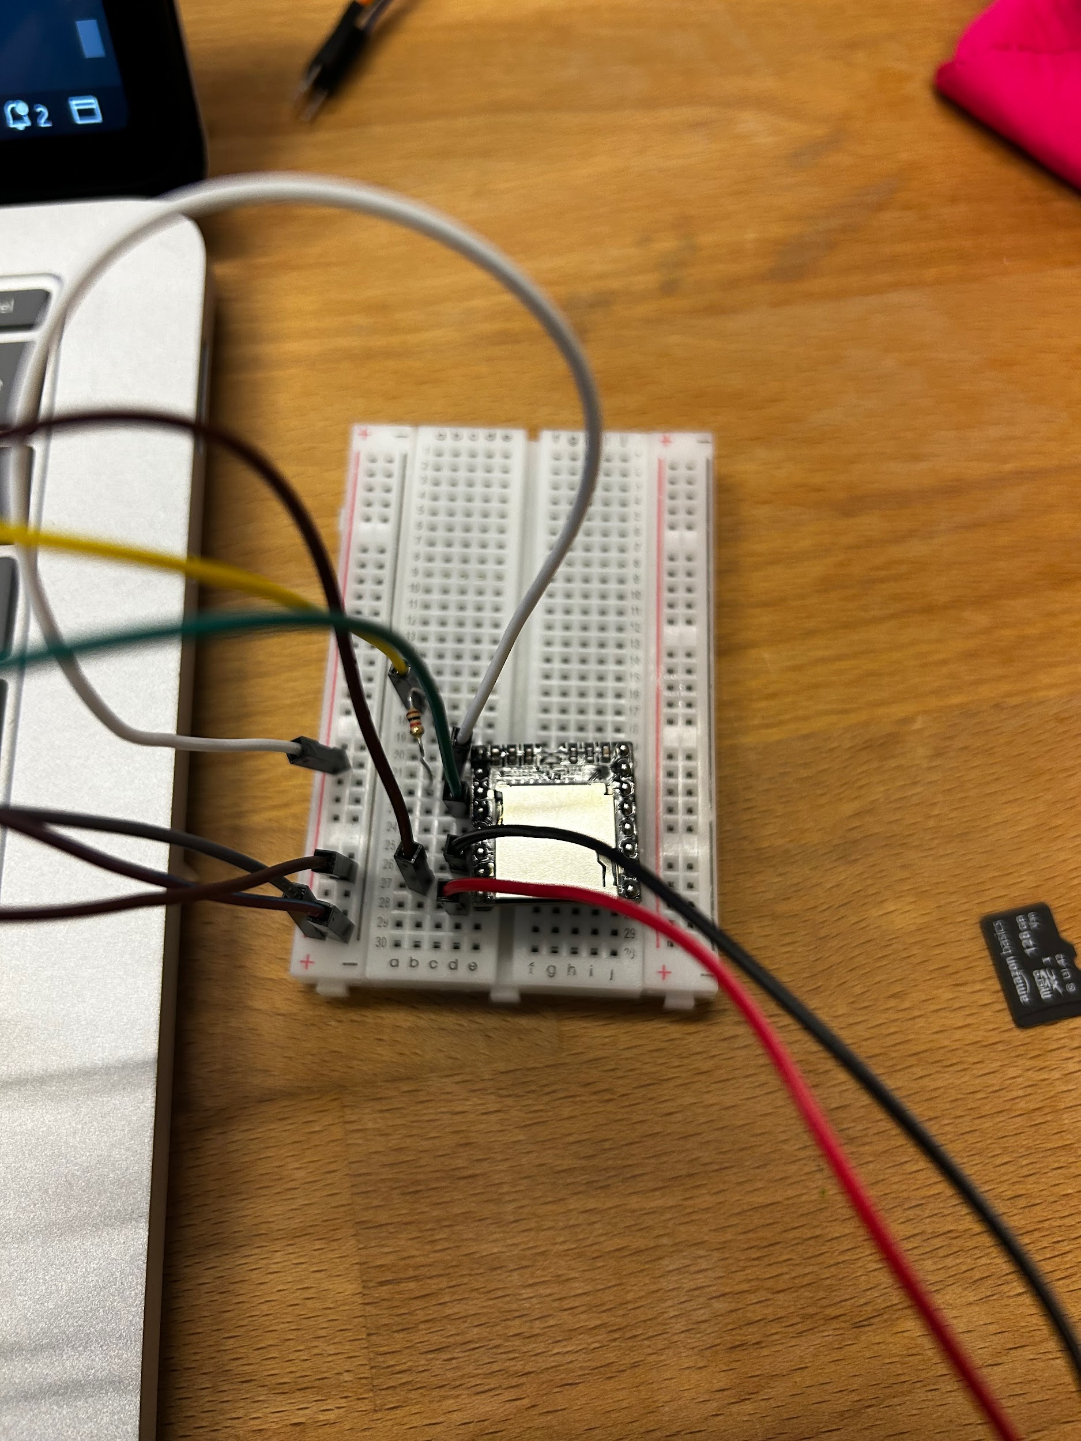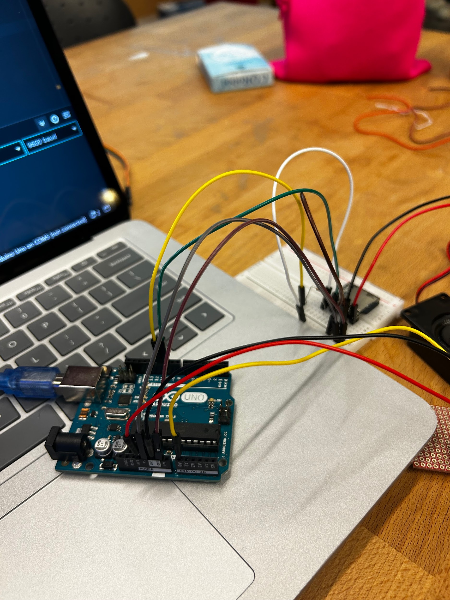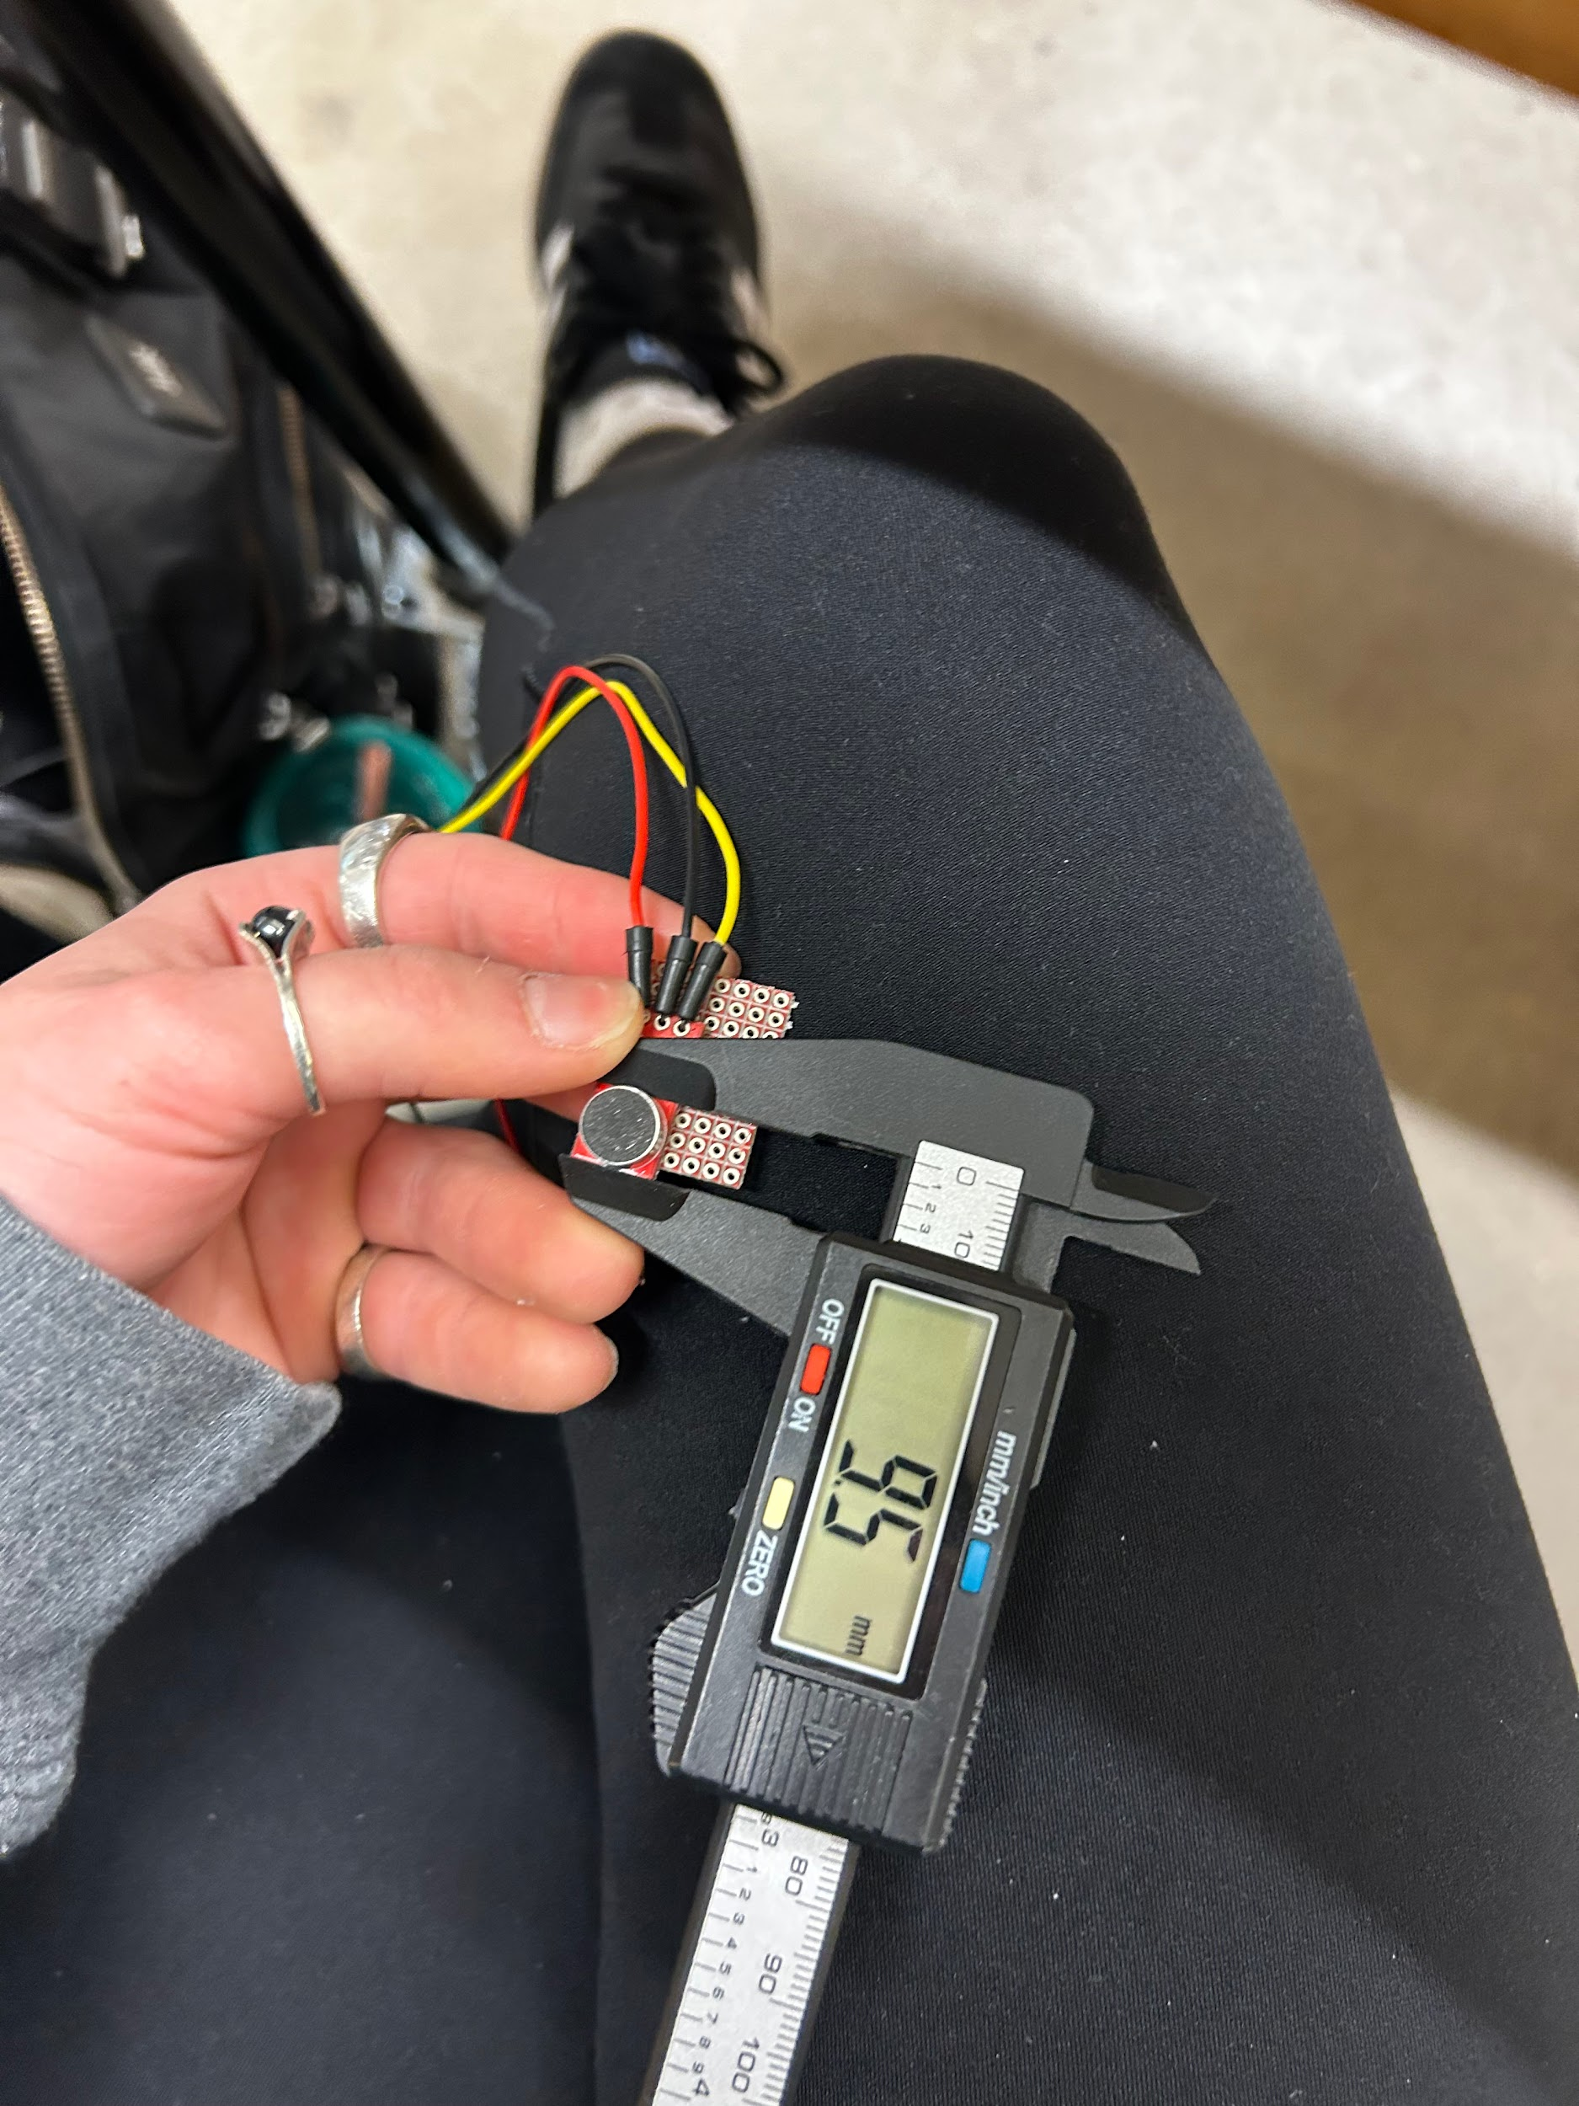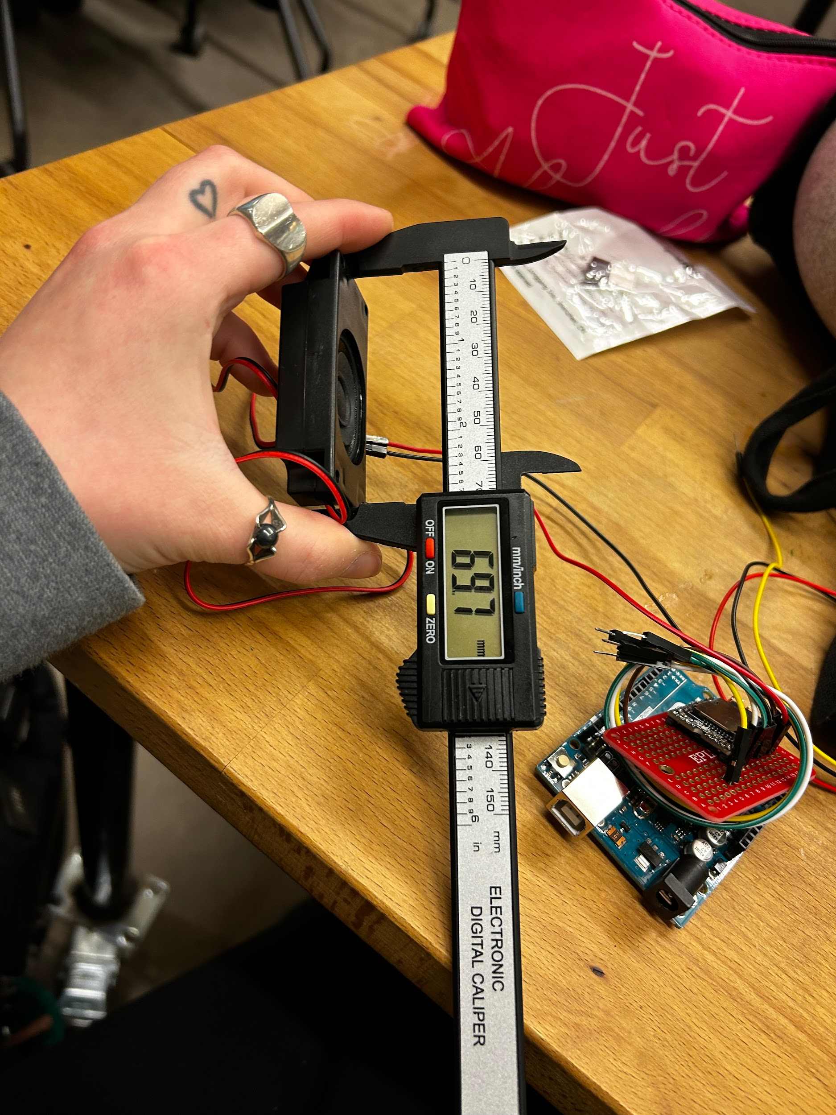

I combined code from arduino tutorials to create code that combines an mp3 player and a sound sensor. This ended up working when I tested it to just play one audio file. But, I needed to implement code that times an interval. I did this with help from the internet. I implemented a millis and an interval of one minute. The code technically worked, but for two weeks me and the LAs could not figure out why the sound values weren’t increasing much when yelling or when music was played. The final week I realized that the sound sensor only responded well to vibrations such as clapping and stomping, not just music. I did some research and figured out that I could use digital read instead of analog to sense the bass in music. This worked exactly how I wanted it to.

1. Enclosure

I decided to create a bear on a box instead of attempting to shove the arduino inside a plastic bear somehow. I wanted it to look like the bear was on a stage speaking into a microphone. The microphone in the stand indicates if the bear is on or not. I printed the first go and the microphone stand immediately broke off because it was too thin. But, most of my components fit perfectly in the box in the way I wanted. Unfortunately, the hole for my power cord was way too small. The bear was also a bit too small for my liking. For my second print I decided to make the stand thicker, make the bear bigger, and make the cord hole bigger.

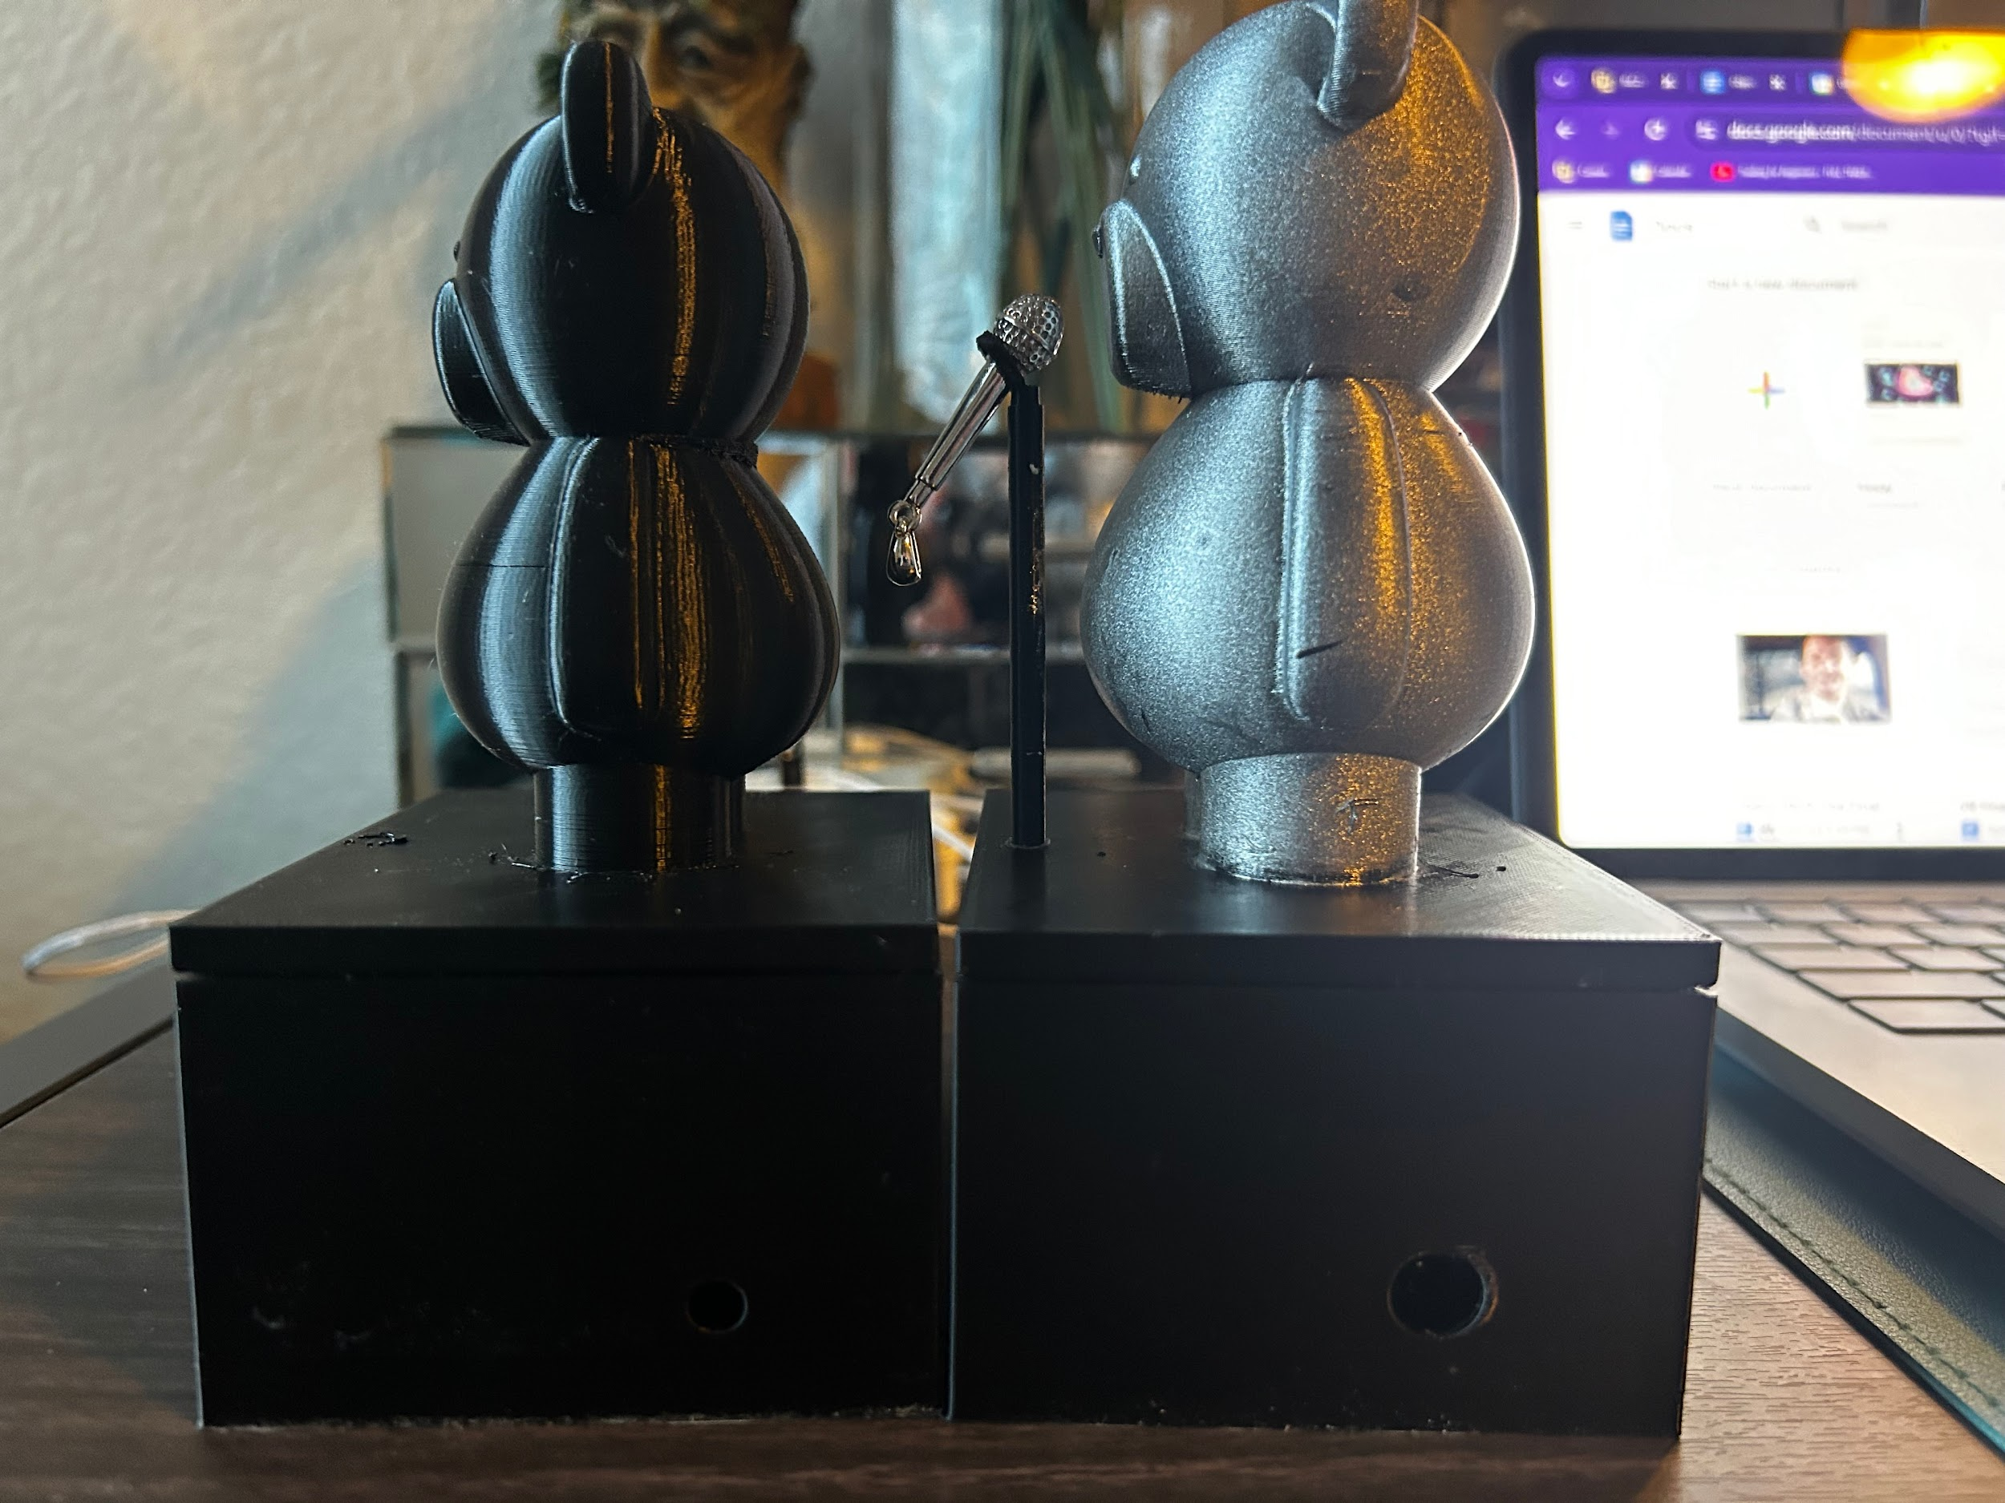

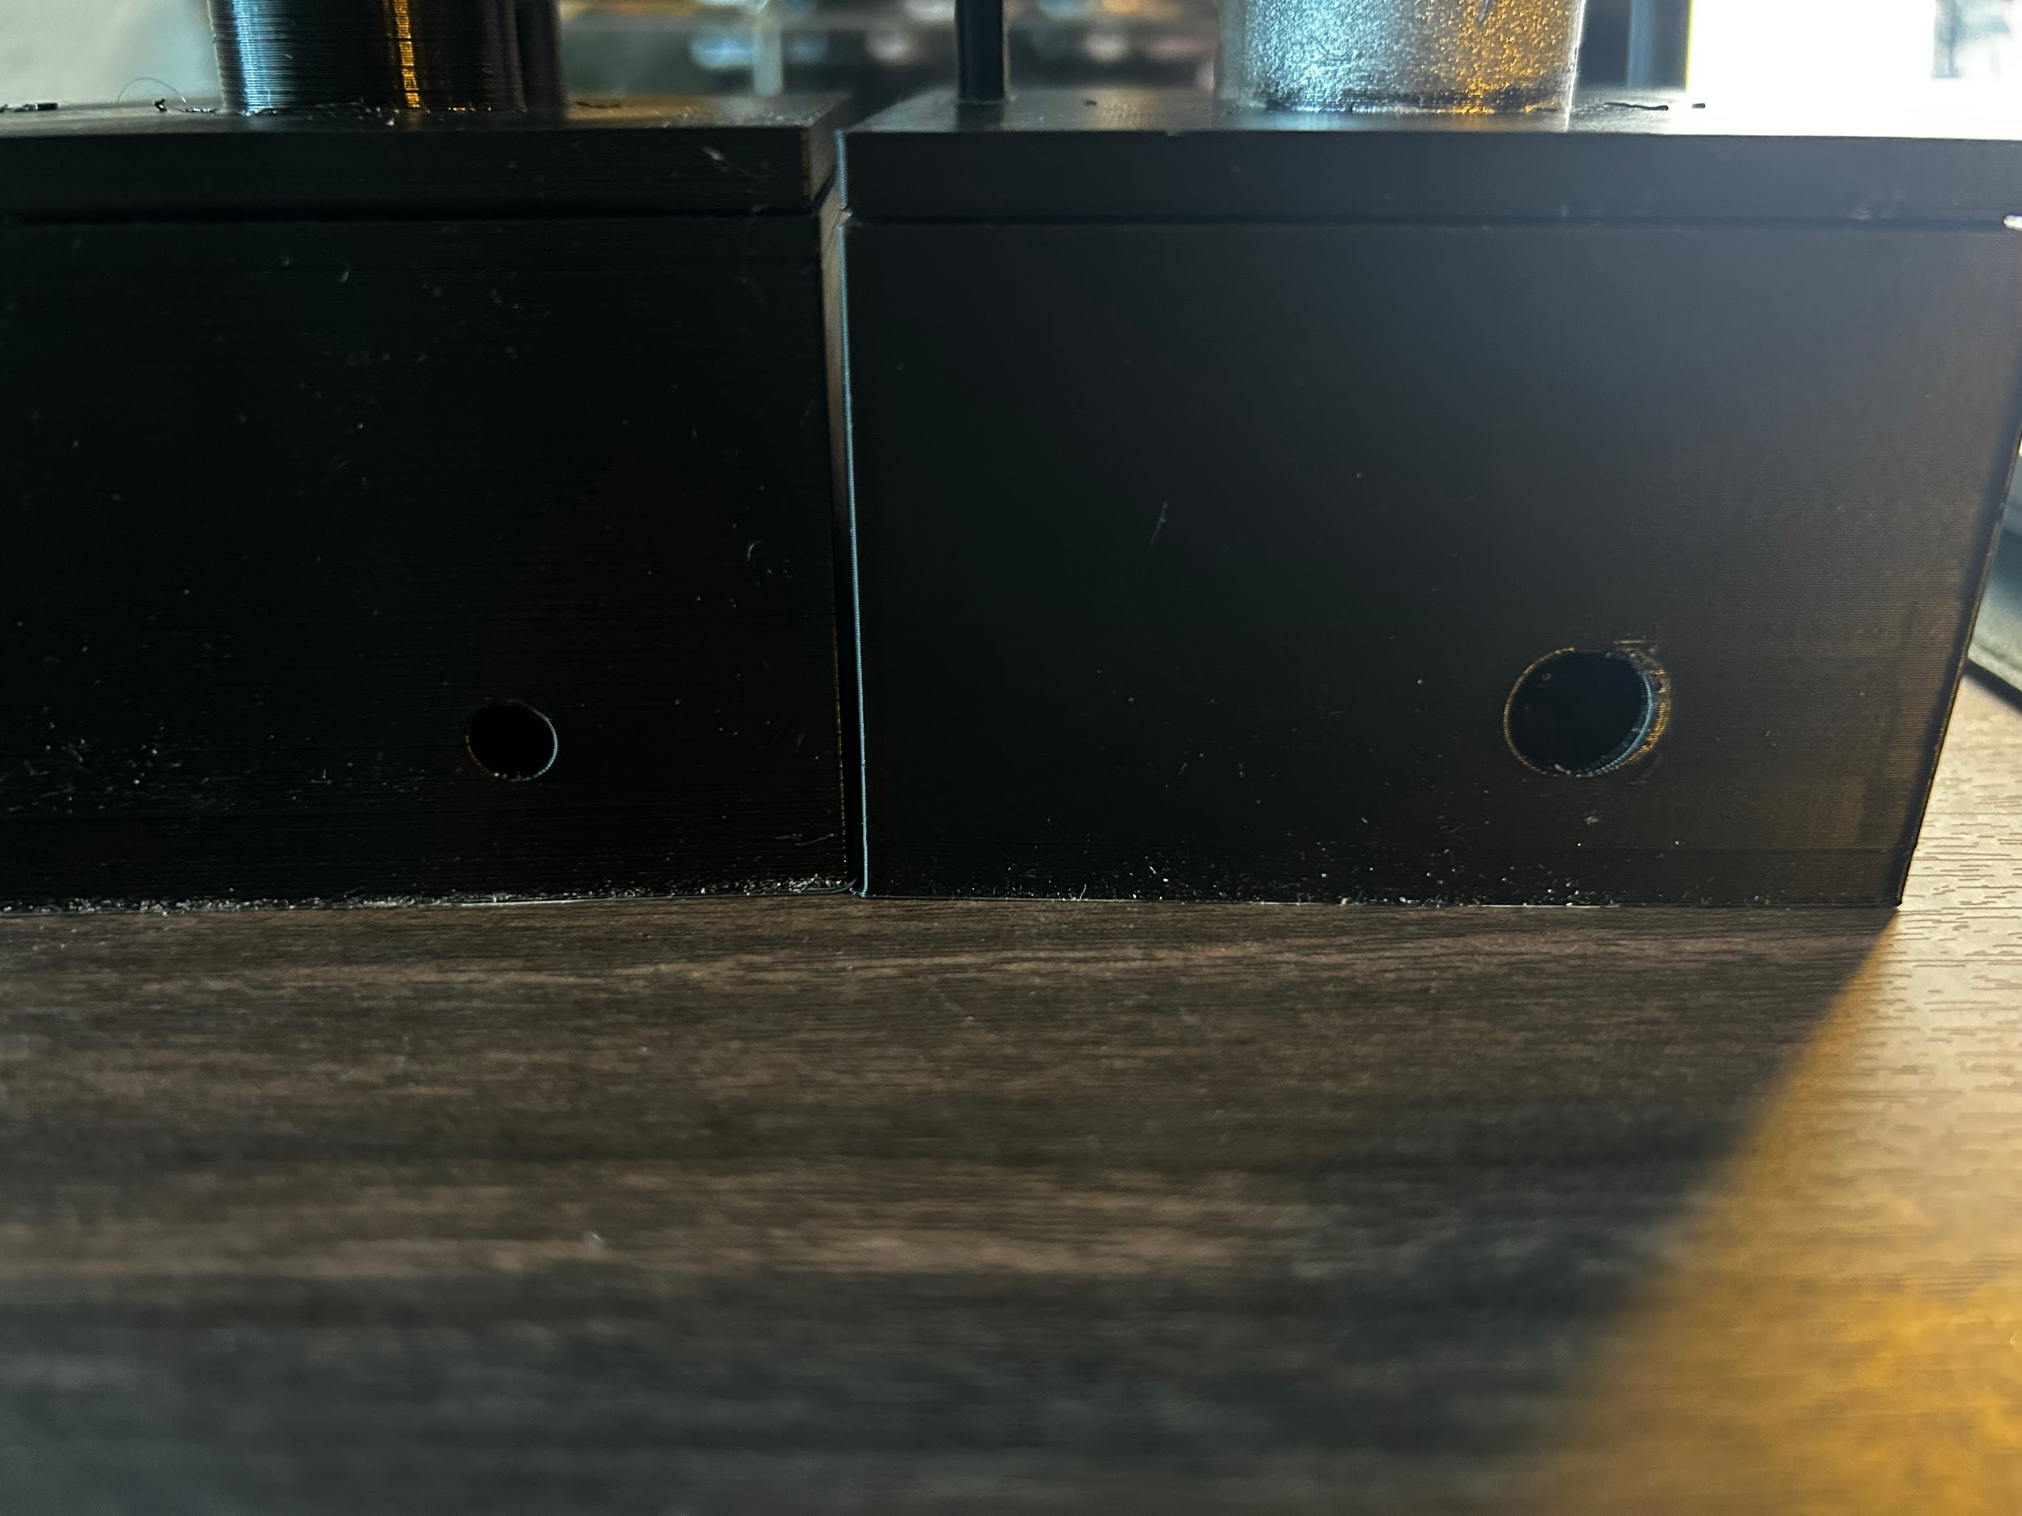

Final photos and a demonstration are in the main part of the folder.